______Cert II IT Mark

Title: | Certificate II in Information Technology
Area: | Technology & Enterprise

Unit Code:
Lesson No. | 08.02 Analysing Jobs

Title:

Notes:
Teacher: | Mr Peter Faulks

Contact:

Timeline:

Due Date

Task 08.02 Analysing Jobs
Collect three (3) positions advertised in the paper that might interest you.

Positions 1 Choose any
1. For each position advertised, answer the following:
  - What qualifications are required?
  - What experience requirements are listed?
  - When does the position become available?
  - When do applications close?
  - What process or next stage do the applicants follow?
  - How many referees are required?
  - Any special conditions stipulated?
  - What is the address for you to send your resume to?
  - Who is the contact person advertising the position?
  - What salary or package is being offered?
  - Why does the position advertised interest you?
2. Apply for a position…
Add - what do you offer any future employers that most other candidates cannot offer? (Be creative)

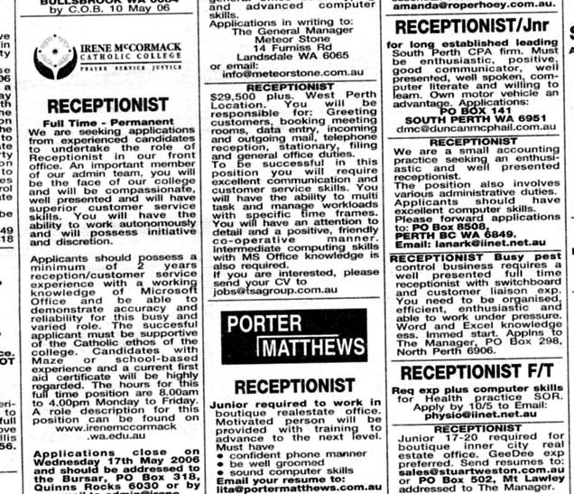

Positions 2 Choose any


Positions 3 Choose any



Positions 4 Choose any



Cut and Print only the pages requested – link your files to the web page

Your Name:

Unit of Competency (Delete not used) :

1,2,3,4,5,6,7,8 (9,10,11,12,13,14,15 or 16)

Task Title: Task Number:

Paste your answers here:

Assessor to complete
Evidence is Valid √ Sufficient √ Authentic √ Current √

Feedback comments:

Assessor signature: ________________________________________

Date: ______________________________________________________

Peter Faulks, BA Soc Sci, Grad Dip Ed, Cert IV AWT
Certificate II in Information Technology assessor/teacher

